BM Connect
“Your Home Between Campus & City”

BM Connect was established to close the gap between most off-campus students, lecturers who require high-quality housing. BM Connect, which was founded by Bonno Moloi, is aware of the difficulties in locating a suitable place to call home. BM Connect can plug you whether you're a lecturer looking for a peaceful and comfortable place, or a student looking for reasonably priced housing close to campus.
- Website Specifications

    - Objective
The aim of this user-friendly website for BM Connect is to act as the main hub for finding high-quality housing in and around the city, for university tutors and off-campus students. Effective online platforms serve as essential hubs for service-based businesses, enabling streamlined user interaction and access to listings (Nielsen, 2020).

    - Goals
- Encourage Relationships: Give prospective tenants an easy way to schedule viewings and ask questions about properties.
- Establish Trust: Establish BM Connect as a dependable, with transparent information, testimonials, and a clear brand.
- Serving Various Audiences: Serve different user groups including lecturers and off-campus students. User-centred design principles emphasise the importance of tailoring interfaces to distinct user personas (Garrett, 2011).
- Produce Leads: To turn visitors into tenants, collect questions via email, phone numbers, and contact forms. Lead generation through digital channels is a core function of modern business websites (Chaffey and Ellis-Chadwick, 2022).
- Showcase Properties: List available lodging options with pictures, costs, features, and location information. Visual property presentation is a key driver of user engagement in real estate and accommodation platforms (Nielsen and Pernice, 2010).

- Target Audience
- Off-Campus Students: students aged 18 to 30 years who are undergraduates and postgraduates, seeking housing near campus, having limited budget and they should be comfortable with websites, mobile apps and online forms.

- Lecturers: University faculty members aged 30-60 years seeking comfortable accommodation in quiet city areas. They should be familiar with professional websites, email communication, and online bookings.

- Type of Website & Content
Website type: Business/Service Website
Content:
Home Page
Property listings
For Students section
For Lecturers section
About Us Page
Contact Us Page
Reviews
FAQ Page
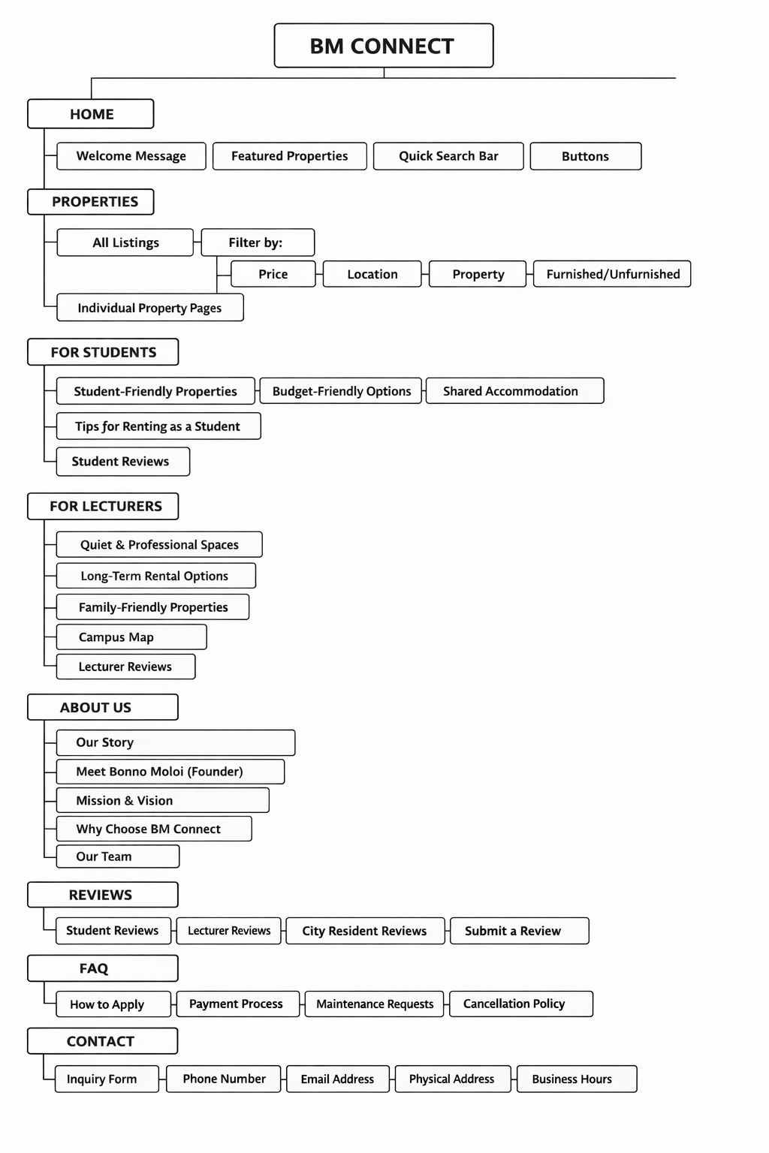
-
- Information Design & Taxonomy

Home Page
The BM Connect landing page. It has buttons for important actions, a welcome message, a fast search bar to locate properties, and a section that highlights available listings with featured properties. Landing pages should communicate value clearly within the first few seconds of a user visit (Nielsen, 2020).

Properties
Users can view all available accommodation on the main property listing page. It has filters to refine results by property type, location, price, and furnishing status. Filtered search functionality significantly improves the user experience on listing platforms (Krug, 2014).

For Students
Listings for shared housing, affordable options, and student-friendly properties are available in a dedicated section for students. It also includes reviews from other students and useful advice for renting as a student. Audience-specific content sections improve relevance and engagement (Garrett, 2011).

For Lecturers
A section designed specifically for academic staff that offers family-friendly properties, long-term rental options, and quiet, professional spaces. It contains reviews from other instructors as well as a campus map that illustrates the university's proximity.

About Us
The company information page presents the mission and vision of BM Connect, tells its story, and introduces its founder, Bonno Moloi. Additionally, it presents the company’s team and explains why clients should select BM Connect. A well-structured About page builds brand credibility and humanizes an organization’s online presence (Fogg, 2003).

Reviews
A page with testimonials from city dwellers, instructors, and students who have utilized BM Connect services. A form for users to submit their own reviews is also included. Social proof through user testimonials is one of the most effective trust-building mechanisms on digital platforms (Cialdini, 2009).

FAQ
A page with answers to frequently asked questions. It addresses topics such as the cancellation policy, how to request maintenance, how to apply for a property, and the payment procedure. FAQ pages reduce support overhead and improve user satisfaction by providing self-service information (Nielsen, 2020).

Contact Us
The page where users can get in touch with BM Connect. It includes the office's phone number, email address, physical address, business hours, and an inquiry form for messages.

- Technical Brief
Technologies Used
- HTML5: Used for the structural layer of the website. HTML5 is the fifth major version of the Hypertext Markup Language and is the standard markup language for creating web pages (World Wide Web Consortium, 2014).
- CSS3: Used for presentation layer and styling. CSS3 provides modular stylesheets that enable flexible and responsive visual design (World Wide Web Consortium, 2011).
- JavaScript: Used for interaction and dynamic behavior. JavaScript is a lightweight, interpreted programming language with first-class functions, widely used for client-side web development (Mozilla Developer Network, 2023).
- Bootstrap 5: Used as the responsive framework. Bootstrap is an open-source front-end toolkit that facilitates the development of responsive, mobile-first web projects (Bootstrap, 2021).

- TEMPLATE DESIGN
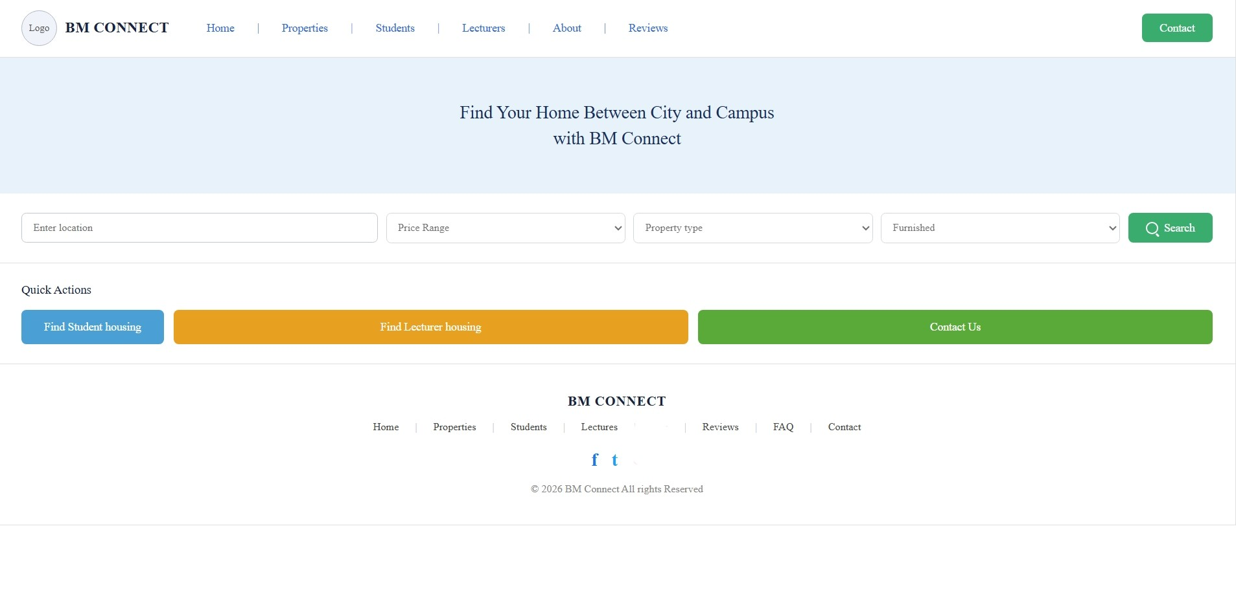
- Properties Link: It is a link on the home page that directs the user to all available properties under BM connect eg apartments and Bachelor pads, their real interior and exterior pictures, where the user can find them as well as the pricing.
- Students Link: Directs the user to the Listings for shared housing, affordable options, and student-friendly properties are available in special advice for renting as a student.

- Lecturer link: Directs the user to the available lecturer properties including their pricing, condition and location.
- About Link: Directs the user to the information about BM Connect and its services.
- Reviews Link: A link to a page with testimonials from lecturers and students who have utilized BM Connect services. A form for users to submit their own reviews is also included.

